DATA ANALYTICS AND VISUALIZATION USING APEX
STUDENT NAME: A S Fathima Arshiya
YEAR:II
COLLEGE CODE: 224
COLLEGE NAME: Wavoo Wajeeha Women’s College of arts & science
DEPARTMENT: Computer Science
SEMESTER:IV
ROLL NO: 24082241802112111
NMID: 78835F0A144269D8F9C4B85DFD5308E7
DATE:18.04.2026
TITLE: Student Performance Analysis using Oracle APEX (Level-2 Implementation)

1. Objective
The objective of Level-2 is to implement the designed system by developing a functional data model, generating reports, and creating interactive dashboards using Oracle APEX. This level focuses on transforming stored student data into meaningful insights for analyzing academic performance.

2. Problem Focus
In Level-1, the system design and planning were completed. Level-2 focuses on implementation by converting the conceptual design into a working application. The challenge is to transform raw data into structured reports and interactive dashboards that allow users to easily analyze student performance, attendance, and trends.

3. Data Model Implementation
The following tables were created in the database:
- Student_Details
  - Student_ID (Primary Key, Number)
  - Name (VARCHAR2)
  - Department (VARCHAR2)
  - Batch (VARCHAR2)
- Course_Info
  - Course_ID (Primary Key, Number)
  - Course_Name (VARCHAR2)
  - Faculty (VARCHAR2)
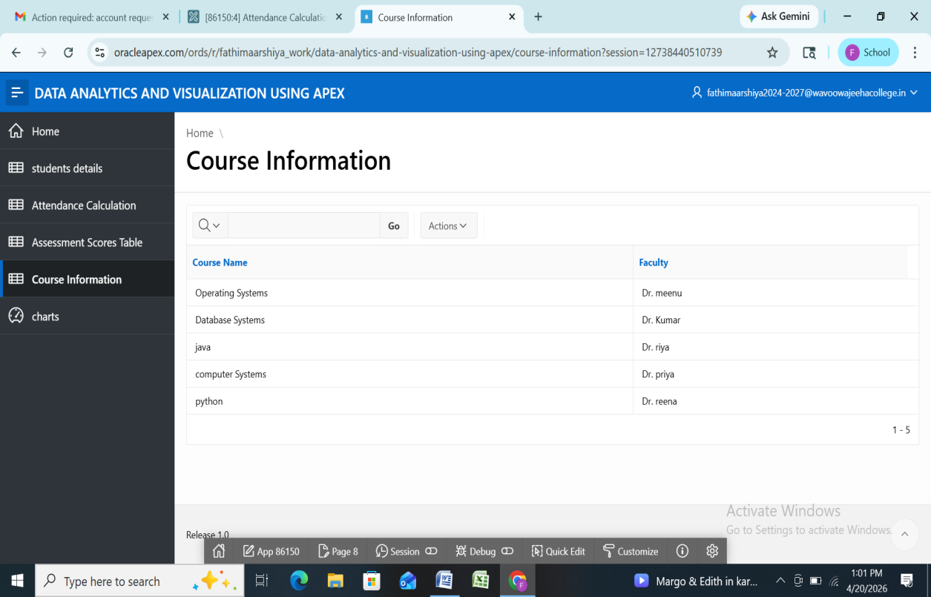
- Attendance_Records
  - Attendance_ID (Primary Key, Number)
  - Student_ID (Foreign Key)
  - Course_ID (Foreign Key)
  - Attendance_Percentage (NUMBER)
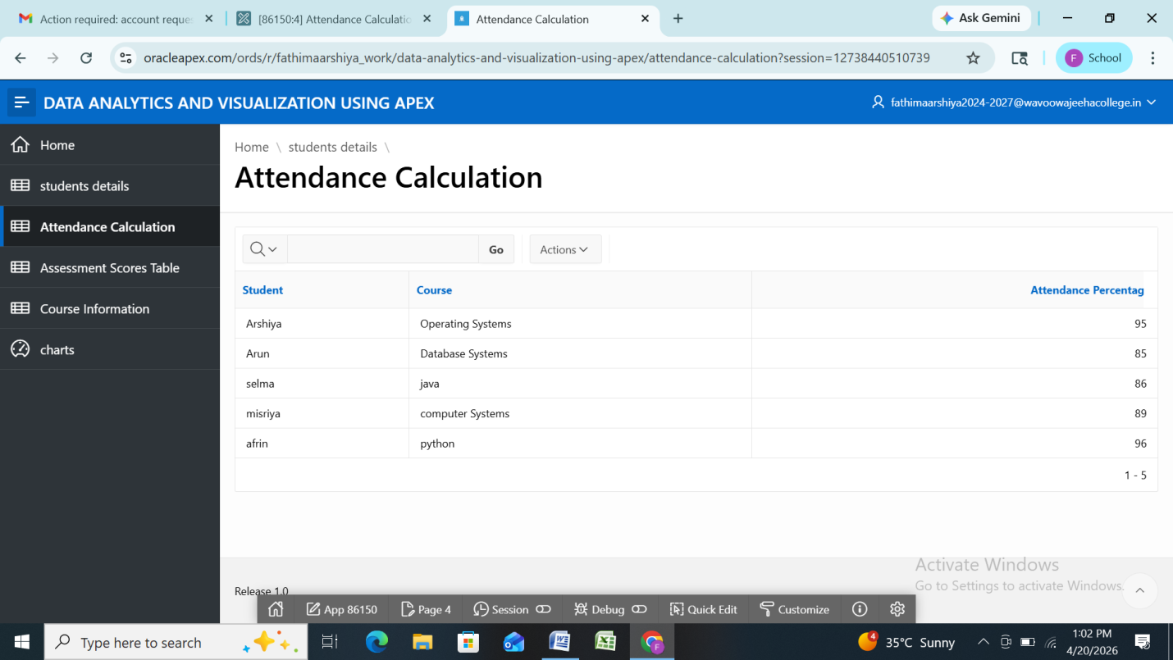
- Assessment_Scores
  - Score_ID (Primary Key, Number)
  - Student_ID (Foreign Key)
  - Course_ID (Foreign Key)
  - Marks (NUMBER)
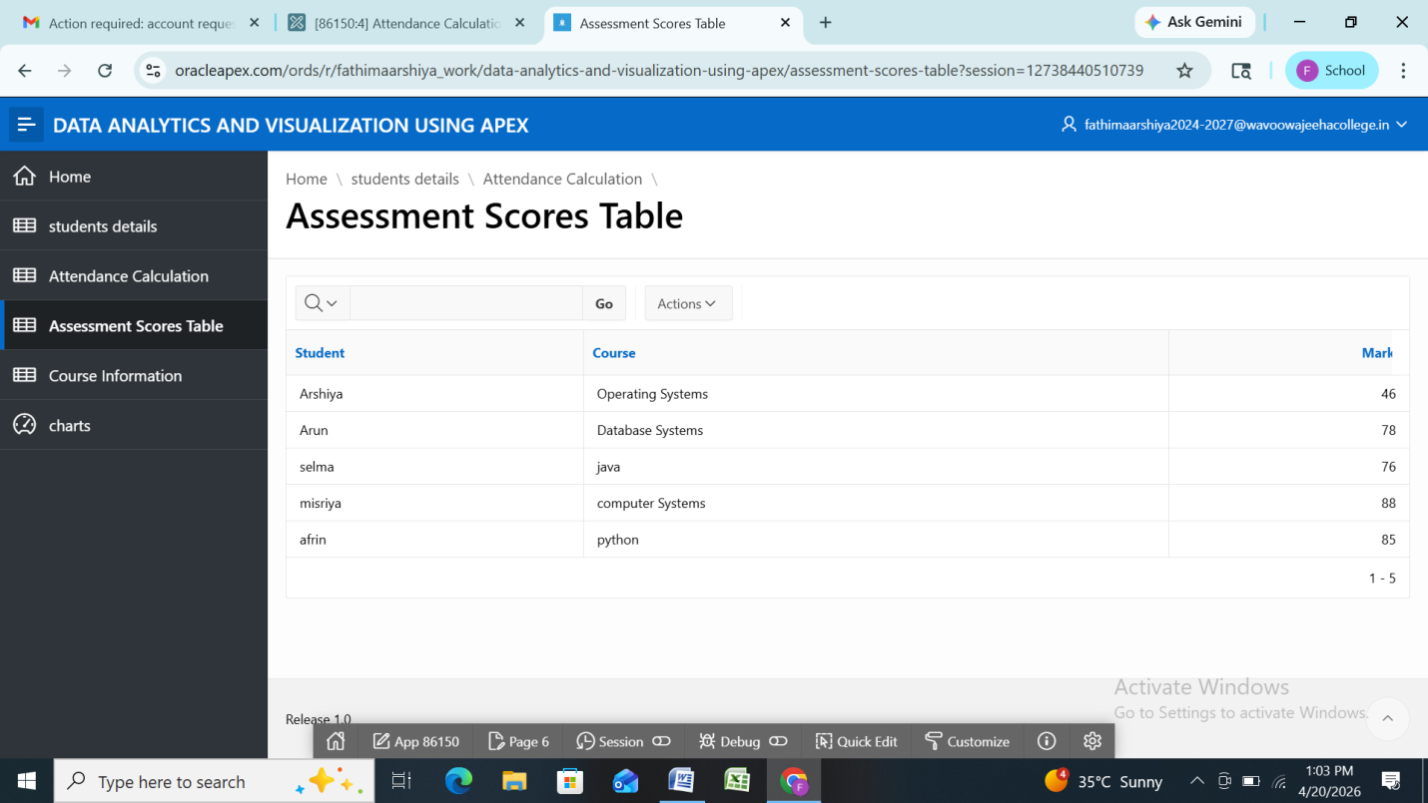
Constraints like Primary Key, Foreign Key, and NOT NULL were applied to ensure data integrity.

4. Data Population
Data was inserted using SQL INSERT statements and manual entry through APEX forms. Around 50–100 records were added across all tables to ensure sufficient data for meaningful analysis. Data consistency and accuracy were maintained during insertion.

5. SQL Queries for Analysis
- Student Performance
SELECT s.name, c.course_name, a.marks
FROM assessment_scores a
JOIN student_details s ON a.student_id = s.student_id
JOIN course_info c ON a.course_id = c.course_id;

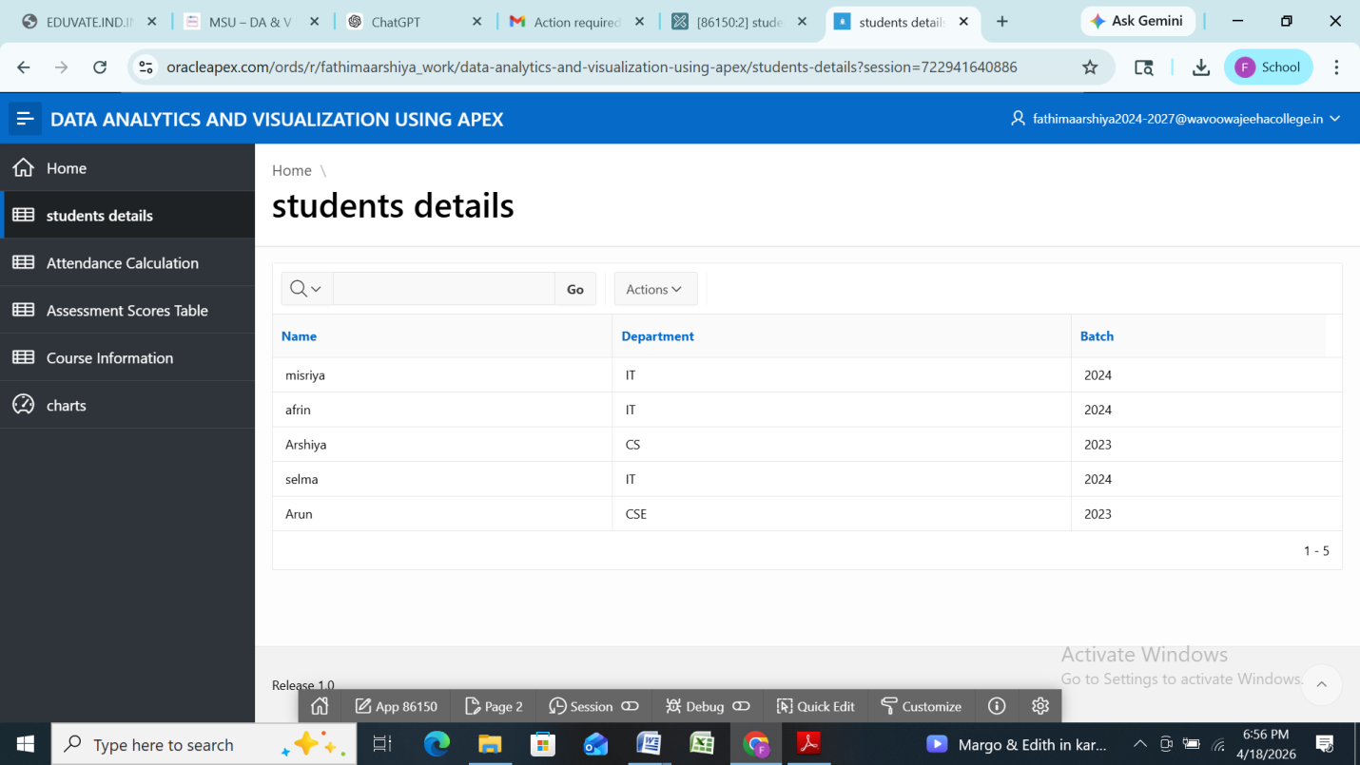
- Attendance Calculation
SELECT s.name, AVG(attendance_percentage) AS avg_attendance
FROM attendance_records a
JOIN student_details s ON a.student_id = s.student_id
GROUP BY s.name;

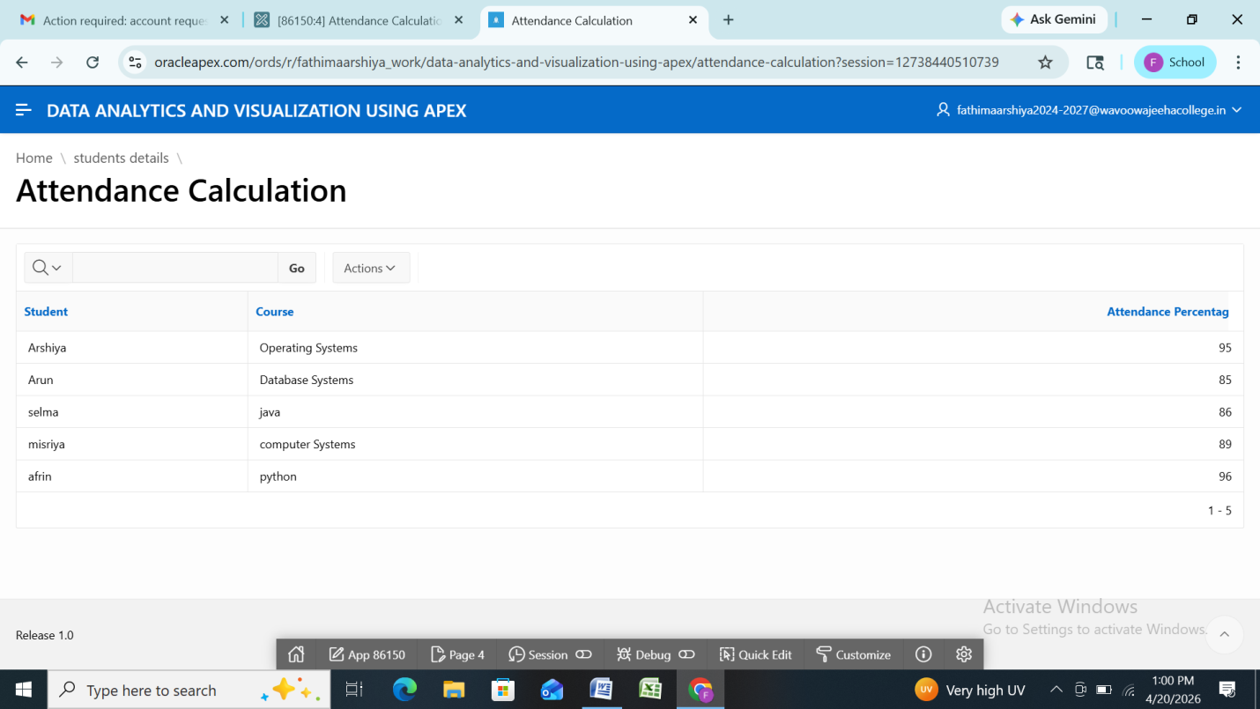
- Batch-wise Comparison
SELECT batch, AVG(marks) AS avg_marks
FROM student_details s
JOIN assessment_scores a ON s.student_id = a.student_id
GROUP BY batch;

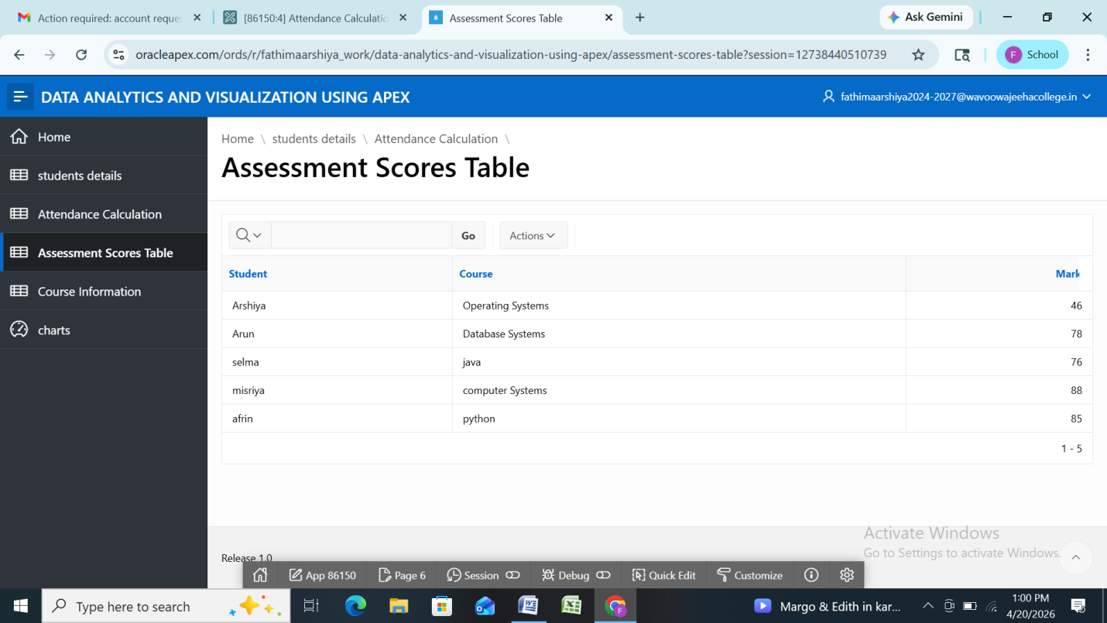
- Low-performing Students
SELECT s.name, AVG(marks) AS avg_marks
FROM student_details s
JOIN assessment_scores a ON s.student_id = a.student_id
GROUP BY s.name
HAVING AVG(marks) < 50;

6. Reports Development
Interactive Reports and Tabular Reports were created in Oracle APEX. These reports include features such as:
- Sorting by marks or attendance
- Filtering by student, course, or batch
- Search functionality for quick access

7. Data Visualization (Charts)
Different chart types were used for better understanding:
- Bar Chart: Comparison of student scores across subjects
- Pie/Donut Chart: Distribution of attendance percentages
- Line Chart: Trends in student performance over time
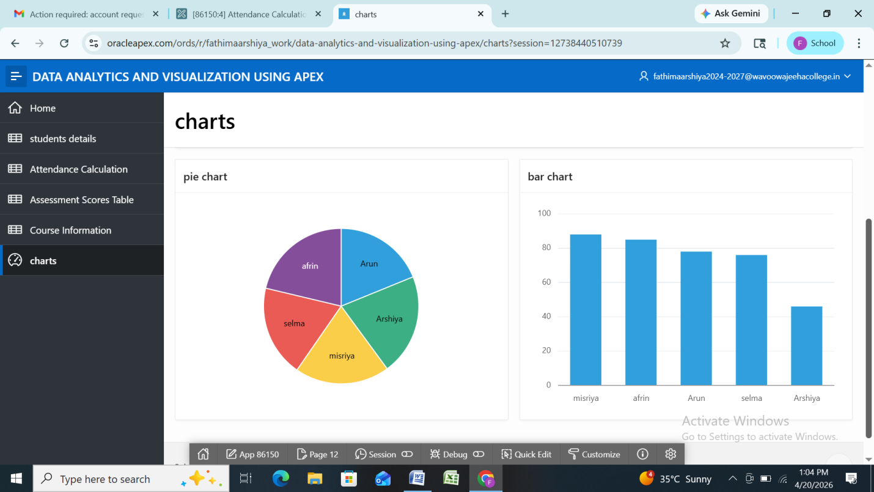
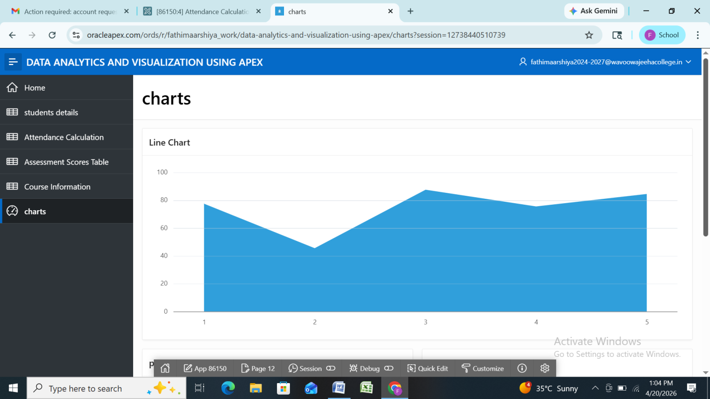

8. Dashboard Design
The dashboard was designed with a structured layout:
- Top section: Summary metrics
- Middle section: Charts (performance, attendance)
- Bottom section: Detailed reports
Navigation between pages allows users to explore detailed insights.

9. Interactivity Features
The dashboard includes:
- Filters (Course-wise, Batch-wise, Student-wise)
- Dynamic actions to update charts based on selection
- Page items for user input and customization

10. Best Practices Followed
- Optimized SQL queries for better performance
- Proper naming conventions for tables and columns
- Consistent UI design across all pages
- Logical and user-friendly navigation

11. Key Insights / Analysis
- Identification of high-performing students
- Detection of students with low attendance
- Batch-wise performance comparison
- Recognition of trends in academic performance

12. Expected Output / Deliverables
- Working Oracle APEX application
- Database tables with sample data
- Interactive reports and charts
- Dashboard with multiple visualizations
- Filters for dynamic analysis
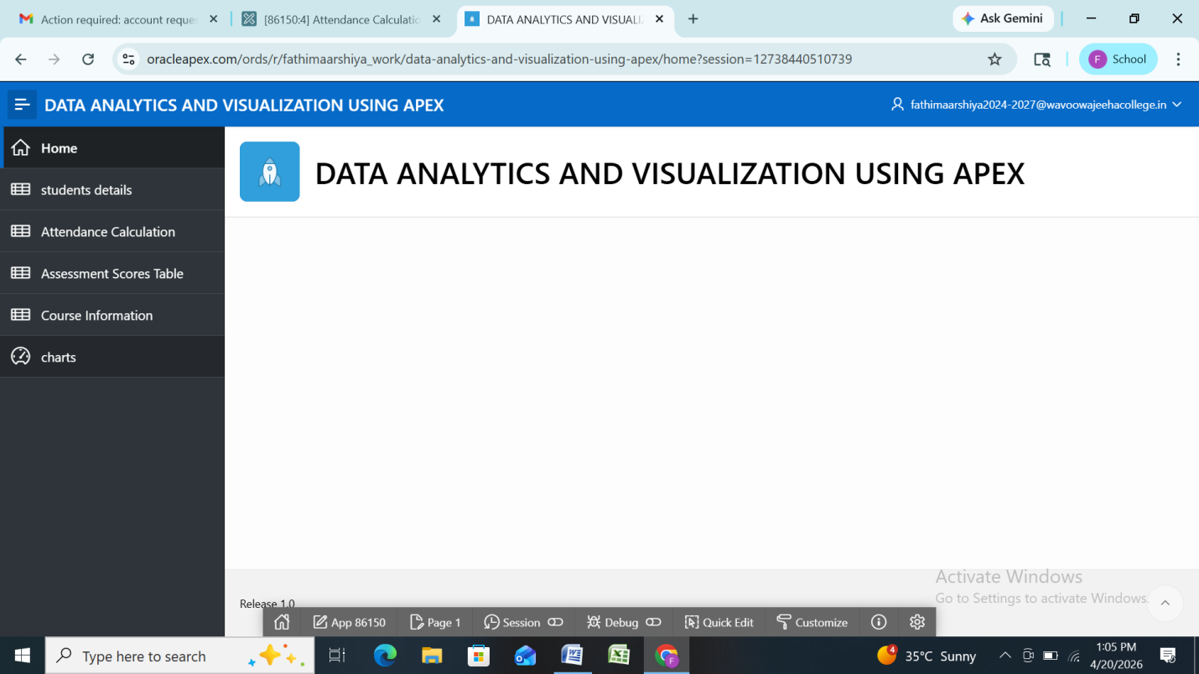

13. Learning Outcome
Students gained knowledge in:
- Oracle APEX application development
- Writing efficient SQL queries
- Creating dashboards and reports
- Data visualization techniques

14. Conclusion
Level-2 successfully transforms the designed system into a functional analytics application. It enables efficient monitoring of student performance and provides meaningful insights through interactive dashboards and reports, making data-driven decision-making easier.

